

**The Polytechnic School**

Sutton Hall, Suite 140

6049 S Backus Mall

Mesa, AZ 85212

(480) 727-1177

Fax: (480) 727-2886

poly.engineering.asu.edu

**IFT 301 – Web Programming for Human Computer Interaction**

**Web Design Project – Final Submission**

**Name: Brandon Trinkle**

**ASU ID: 1217455031**

**Date: 4/20/2024**

**Instructions:** Congratulations! You have finished the web design project! Use the questions below to have a written discussion about your experience completing the web design project.

**Before submitting this assignment, make sure you have met all these requirements:**

* You have completed this worksheet
* You have at least six (6) but no more than (8) pages in your website
* Each page contains appropriate content that is useful to your target audience
* Each page contains an appropriate page title
* You must include at least one (1) form with a minimum of four (4) fields (your form must be part of the HTML code, linking to a Google form or other form from another website is not allowed)
* You must include some JavaScript or jQuery functionality that is useful to your target audience and that has at least two (2) functions and uses form data
* You must use an external stylesheet with a minimum of six (6) CSS declarations
* You have included the URL for the HOME page of your web design project at the end of this document

1. Now that you are finished with your project, the website might be quite different than what you originally planned. Discuss in detail any changes you made to your original plans. If you did make changes, discuss why you made these changes.

I changed the color scheme from what I had originally intended. I wanted a black and gold theme, but it just didn’t look good. So I changed to a white, dark blue and orange theme. I actually was visiting websites looking at their designs, and I really liked those colors so I adopted those into mine.

1. Discuss in detail why you chose the design layout you did. Are you happy with the outcome? Did you run into any issues with your design while developing your site? What did you do to overcome those issues? Would you do anything differently the next time you designed a website?

I am very happy with the outcome and I do plan to launch it. It came out exactly how I intended it to look. I think it looks like a professional website that I would expect a contractor to have. As someone who looks for things on the internet, how your host page is laid out is very important to customer engagement. I know if a website looks poorly put together, I would assume that it’s a reflection of their work.

1. You likely encountered challenges while working on your web design project. Discuss in detail the challenges you encountered and what you did to overcome them.

The biggest challenge was learning the different syntax associated with the CSS designs. For example, for text size – there is an option for 20pt and 20px. 20pt is not 20 point (as you would expect) to change the size of the text you need to use px as the suffix. So exploring different syntax and looking for different animations and features was probably the most challenging. I learned a lot from the labs where we put some of these styles to use.

1. Describe at least three (3) things you learned while working on your web design project that you found interesting and useful.

I have never used HTML or CSS before, so everything we completed during this course is completely new. I have used JavaScript for years, so very familiar with that (mostly made applications that run through the terminal). So the three things I learned were formatting an HTML file, formatting a CSS file, and mostly learning about different CSS styles and syntax associated with them.

1. Is there anything you would have liked to incorporate into your web design project that wasn’t covered during this course? Is there anything you wish we would have spent more time on during this course?

I think this course was perfect. All of the work assigned was necessary to learn, not un-necessary, or non-value-added work. We had enough time to spend on building our website.

1. While trying to be as objective and unbiased as possible, please go through and critique your web design project using the attached rubric. In the “Student Critique” column, indicate which score you should receive for each category and write a short (one or two sentences maximum) justifying that score.

**Student Critique**

|  |  |  |  |  |
| --- | --- | --- | --- | --- |
|  | **Outstanding** | **Average** | **Needs Improvement** | **Student Critique** |
| **Example** | You did everything correctly. | You did some things correctly. | You did nothing correctly. | Outstanding – I believe I did everything correctly because of x, y and z. |
| **Discussion Questions: Answers** | Clearly and completely answered the questions. | Answers to questions could have been more complete or more clear. | Answers were very short or missing. | Outstanding – I answered all the questions and provided context as to why that was my answer. |
| **Discussion Questions: Mechanics** | Organized, neat in appearance, easy to read and understand. | Somewhat organized and neat in appearance; the document is mostly easy to read and understand. | Answers were very short or missing. | Average – I tried to go through the CSS page and clean up any redundant or duplicate styles. However, I still believe I missed some. That is why I put average and not outstanding. |
| **Visual Appeal** | Use of color, contrast, text, graphics, etc. is appealing to target audience. | Use of color, contrast, text, graphics ,etc. is somewhat appealing to target audience. | Use of color, contrast, text, graphics, etc. is not appealing to target audience. | Average – I am not a good visual designer, I’m not creative. I lean more towards functionality than how it looks. I did try my best, but I know some students are more creative than I am. |
| **Navigation** | Easy to get anywhere in the site; consistent organization | Somewhat easy to get from one page to another; mostly consistent organization | Hard to get from page to page; inconsistent organization | Outstanding – Header with links to each page is displayed on the header of every page. Main page has multiple links to other pages depending on user preference. |
| **Page Titles / Logo Area** | Descriptive and include the site/company name | Somewhat descriptive and include the site/company name | Missing or does not include the site/company name | Outstanding – logo is on header and footer with © in the footer. Contact information displayed multiple times throughout the website. |
| **Graphics** | Appropriate for the content; uses the correct syntax (tags and attributes) | Somewhat appropriate for the content; uses the correct syntax (tags and attributes) | Inappropriate for the content; uses incorrect syntax (tags and attributes); missing | Average – As I have stated earlier, I am not a good visual designer. I understand other students are better at this than I am. However, I do like how it looks and I am happy with the work I submitted. |
| **Form** | Contains 4 or more inputs; uses the correct syntax | Contains less than 4 inputs; uses the correct syntax | Contains less than 4 inputs; does not use correct syntax; missing | Outstanding - My form validation contains four entries (name, phone, email, description) Name must be two words, phone number must be XXX-XXX-XXXX, email must be formatted like such [name@email.com](mailto:name@email.com), and description must be 25 characters. |
| **JavaScript** | Useful and appropriate for content; uses correct syntax (no console errors); has at least two (2) functions and makes use of form data | Somewhat useful and appropriate for content; uses mostly correct syntax (less than 2 console errors); has at least two (2) functions and makes use of form data | Not useful or appropriate for content; uses incorrect syntax (more than 2 console errors); has less than two (2) functions and does not make use of form data | Outstanding – I have three JS scripts in my website. Two photo slide shows and one form validation. |
| **CSS** | Uses external stylesheet with at least six (6) declarations; no errors | Uses external stylesheet with at least six (6) declarations; less than 2 errors | Does not use external stylesheet; less than six (6) declarations; more than 2 errors | Outstanding – My CSS file is over 700 lines. Super happy and proud of the work I put into it. |
| **HTML** | Neat and indented properly; uses correct syntax; | Mostly neat and indented properly; uses mostly correct syntax | Messy and not indented properly; uses incorrect syntax | Outstanding – I think my HTML flows very well, displaying the content clearly. It calls the scripts and photos correctly. |

1. Insert the browser view screenshot of page #1 here.

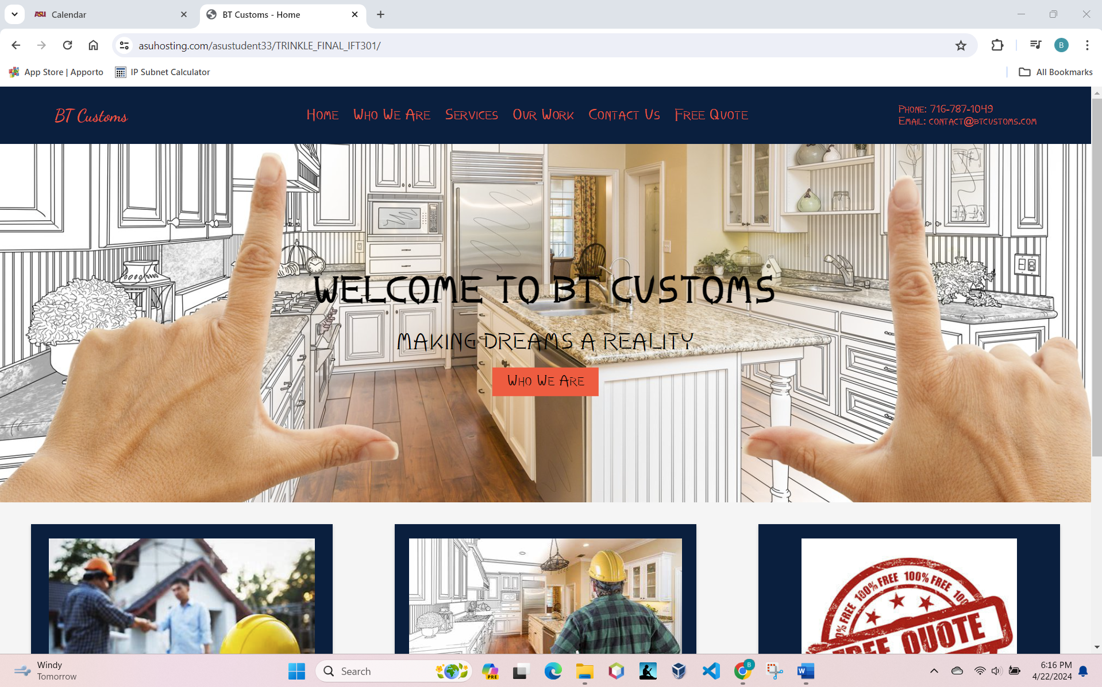

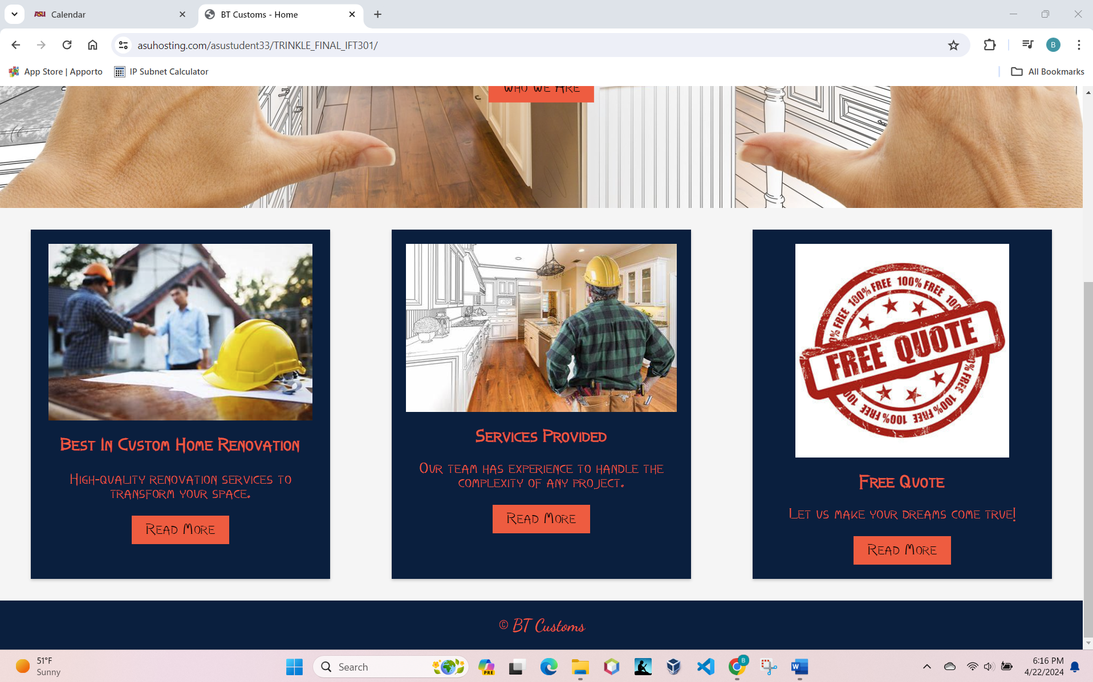

1. Insert the browser view screenshot of page #2 here.

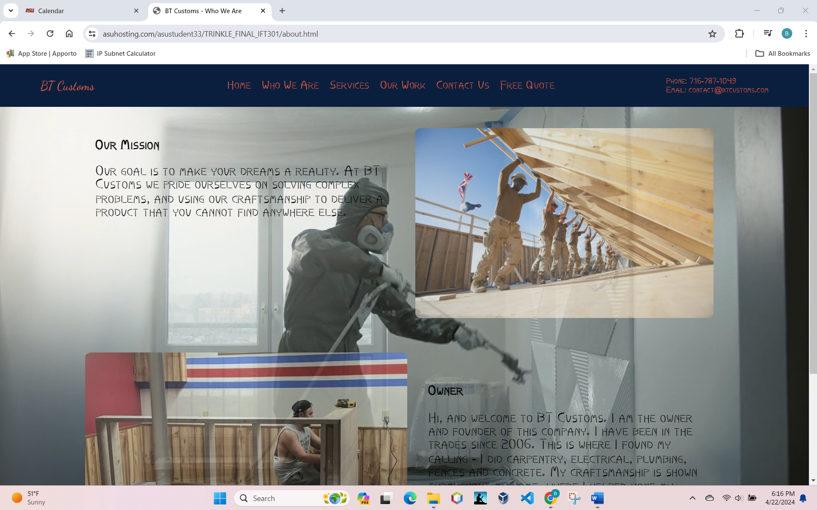

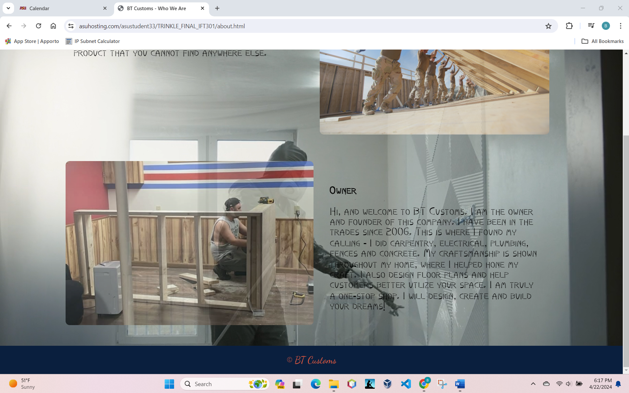

1. Insert the browser view screenshot of page #3 here.

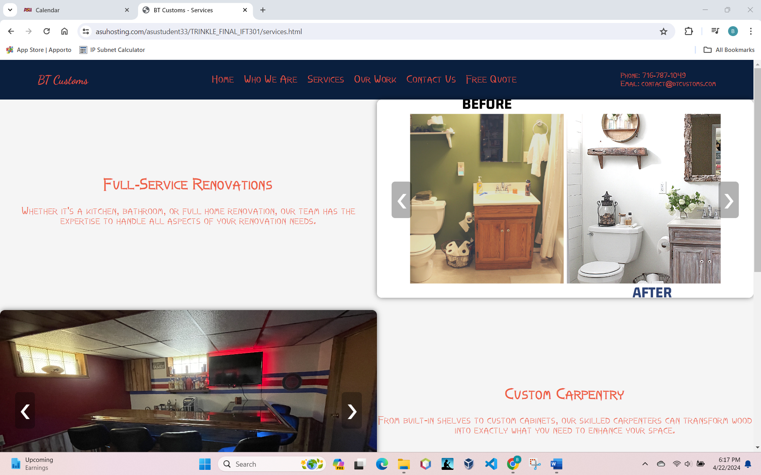

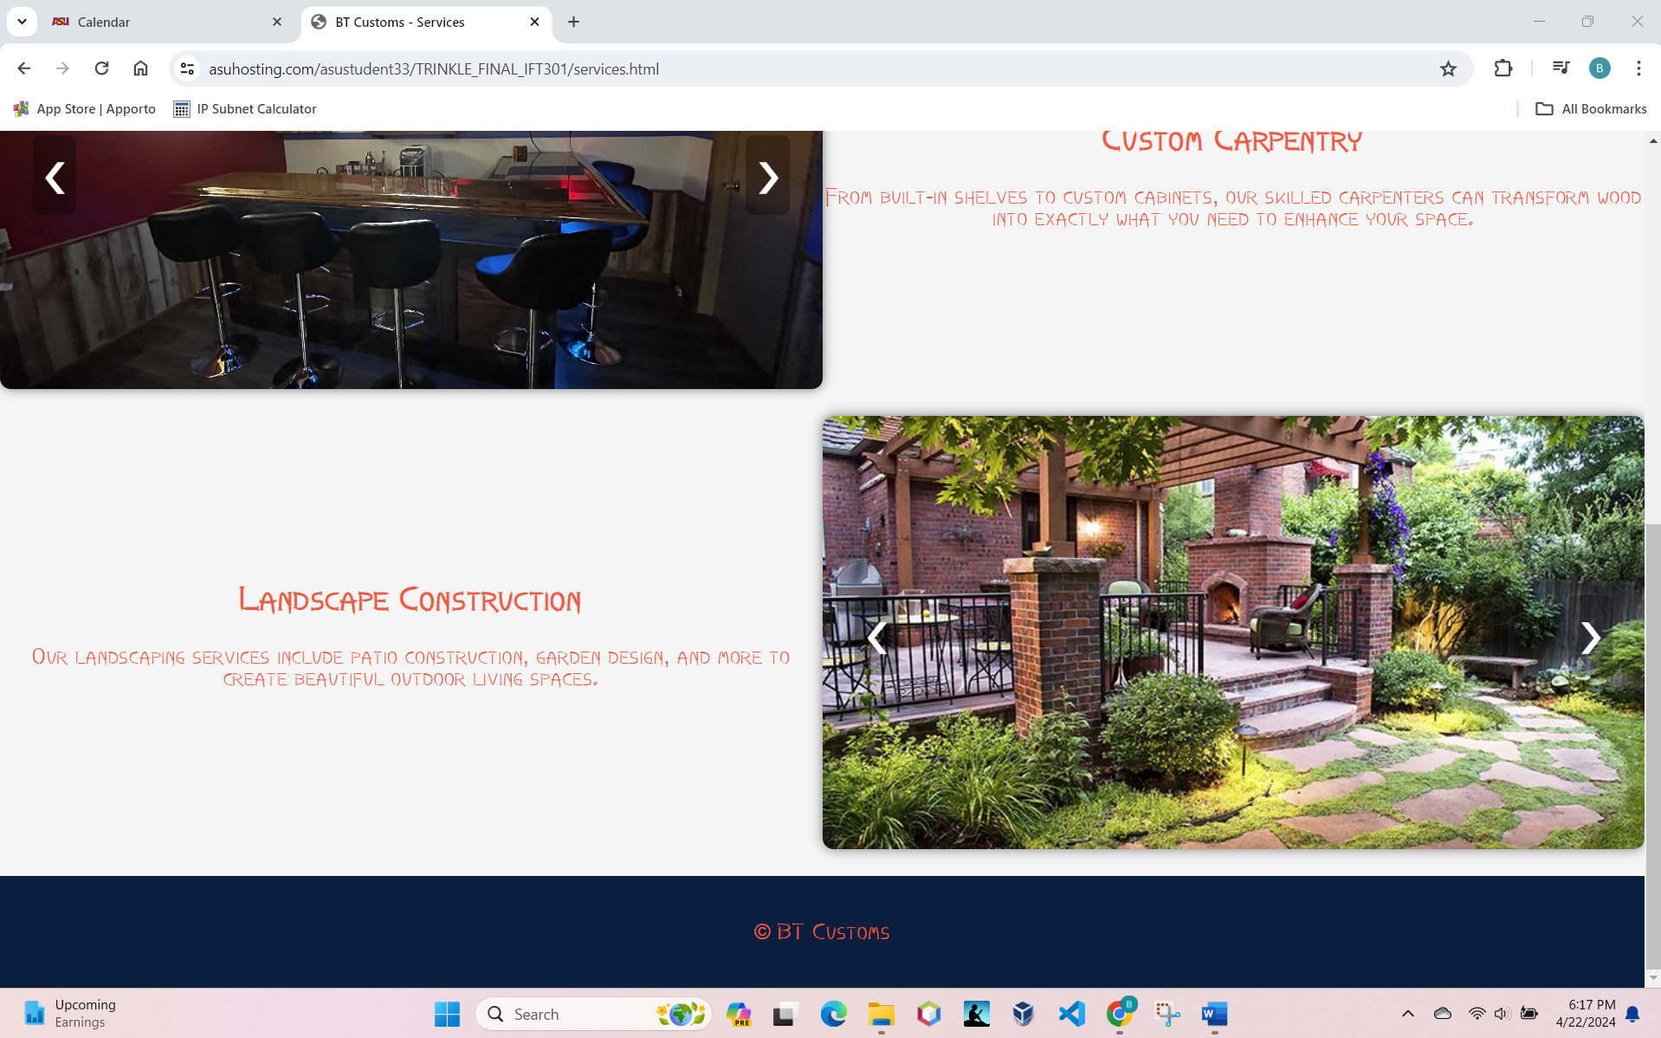

1. Insert the browser view screenshot of page #4 here.

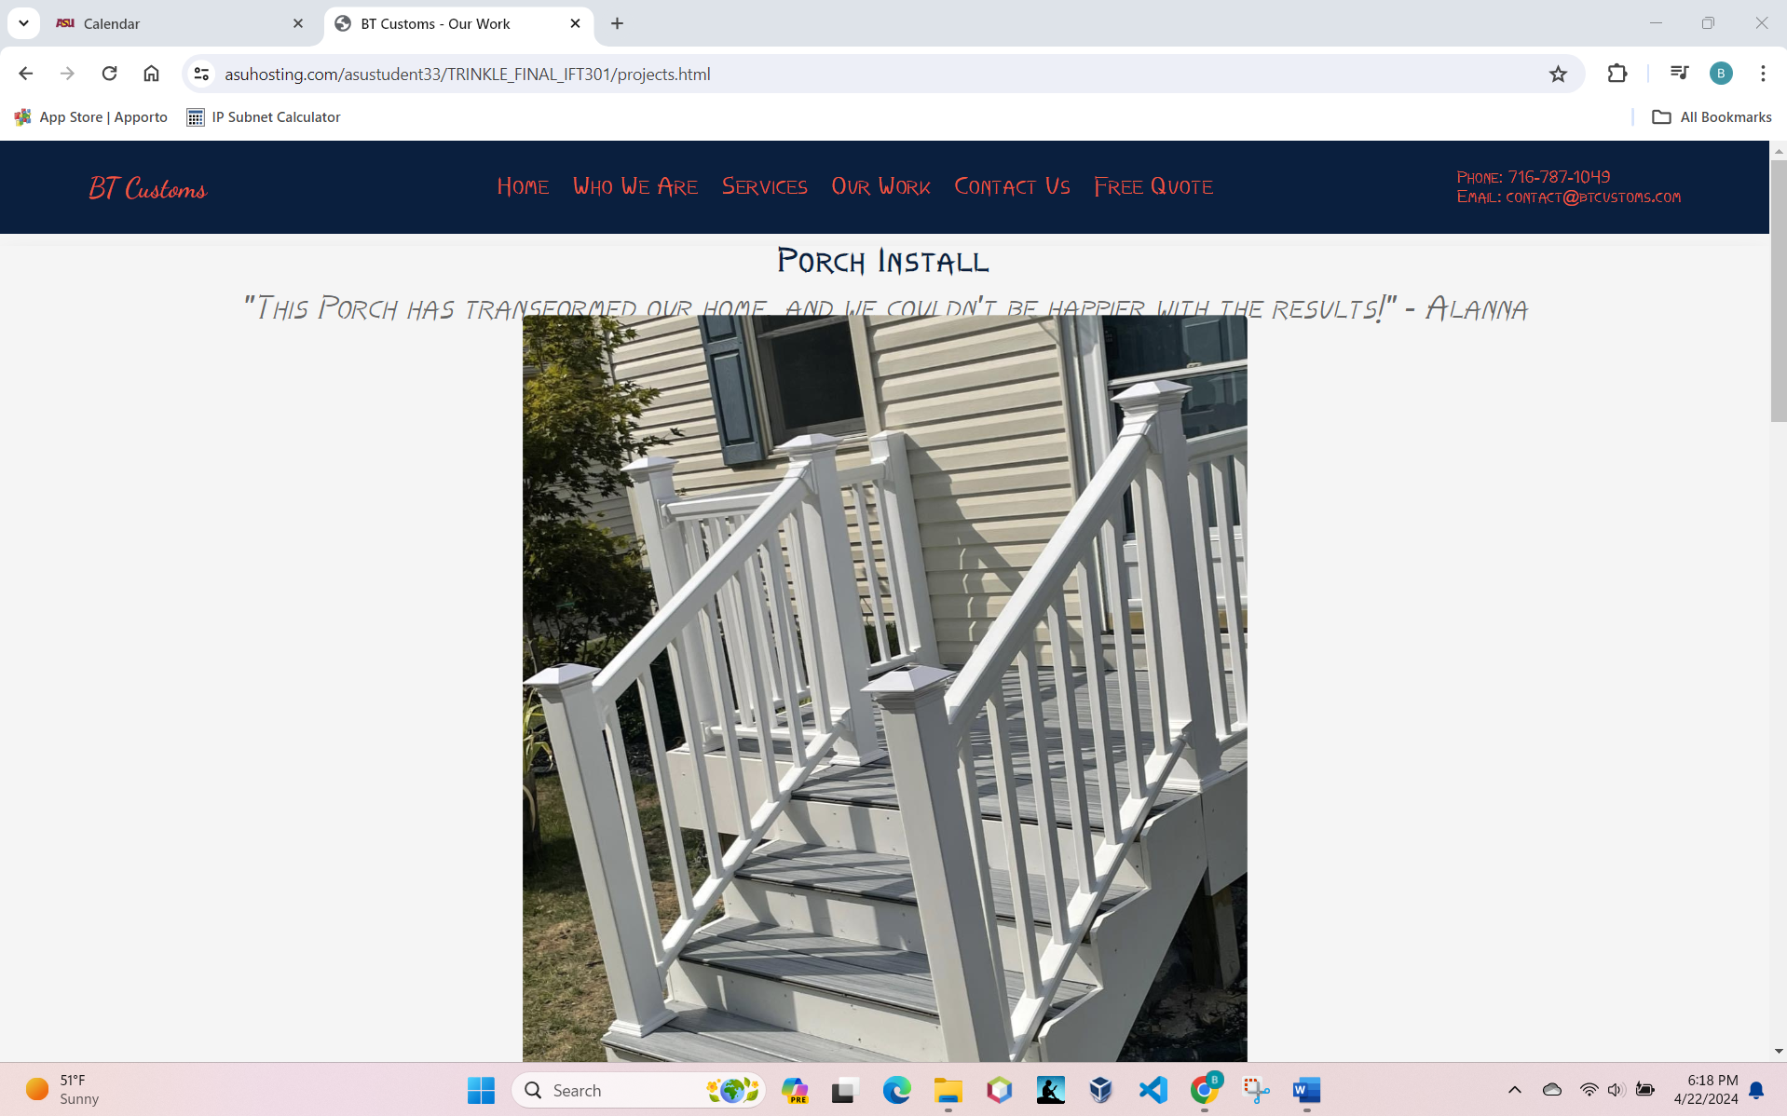

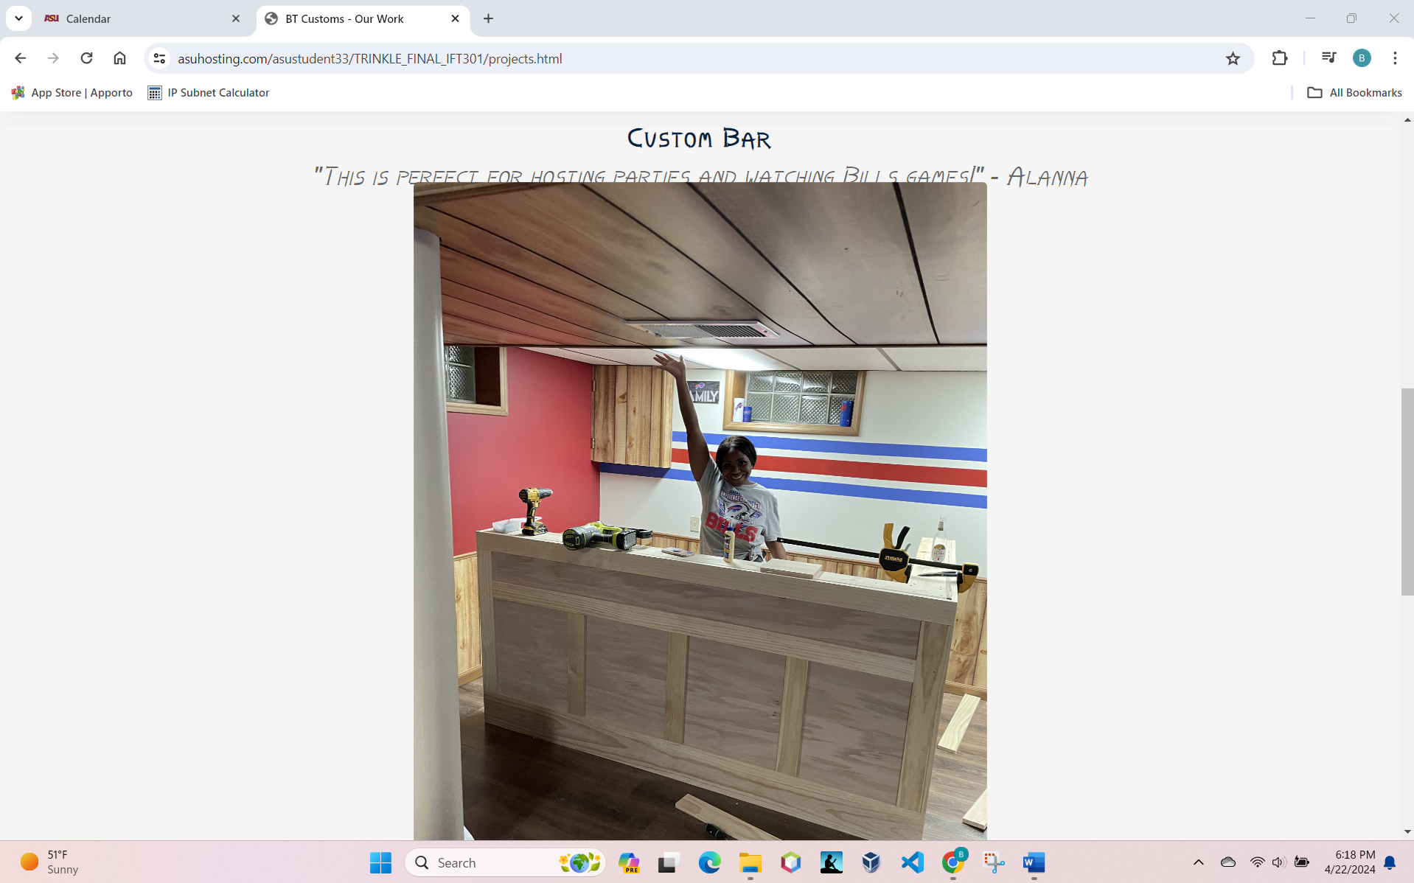

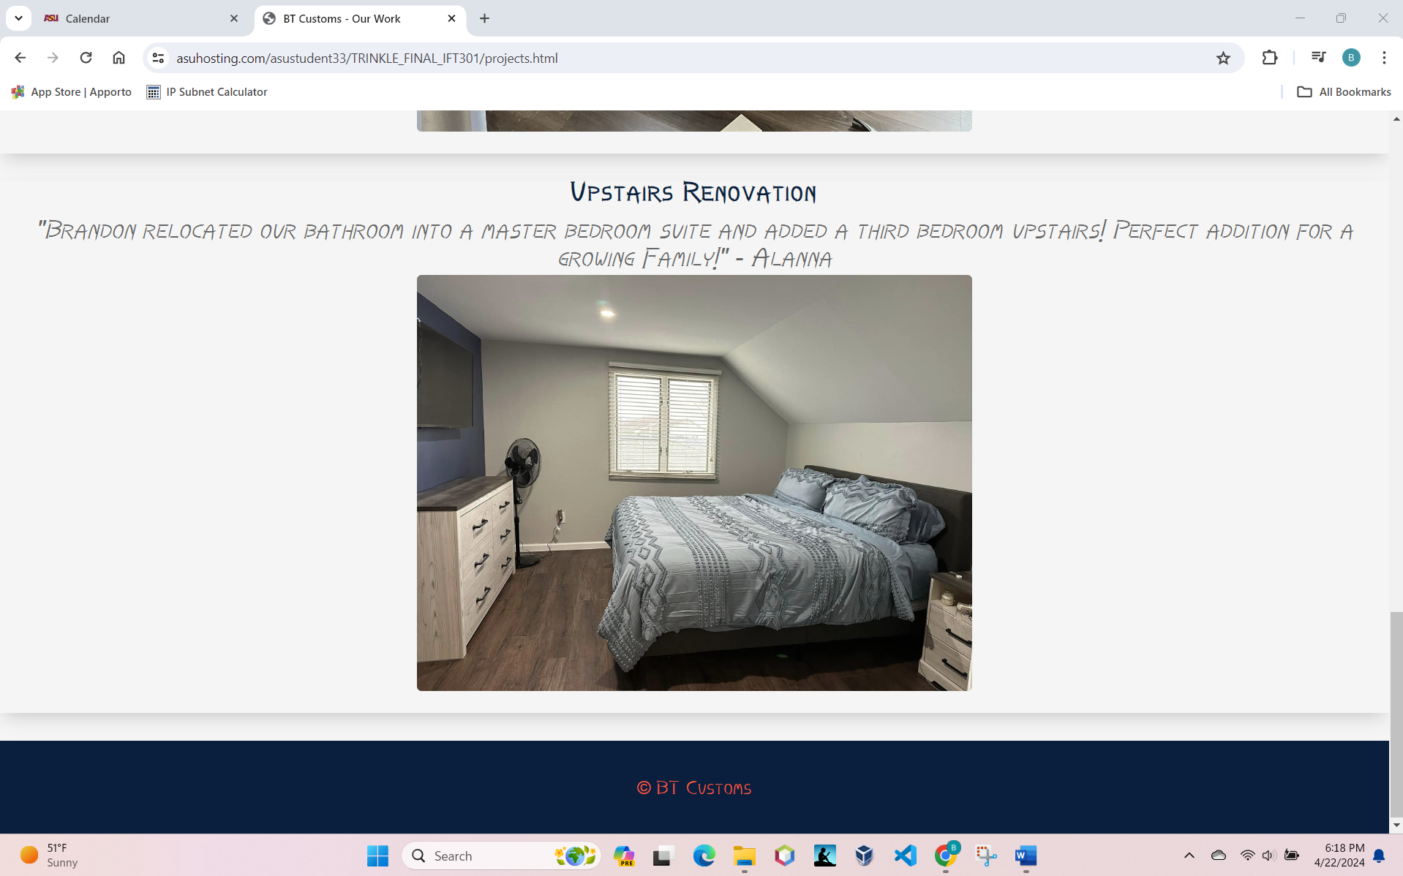

1. Insert the browser view screenshot of page #5 here.

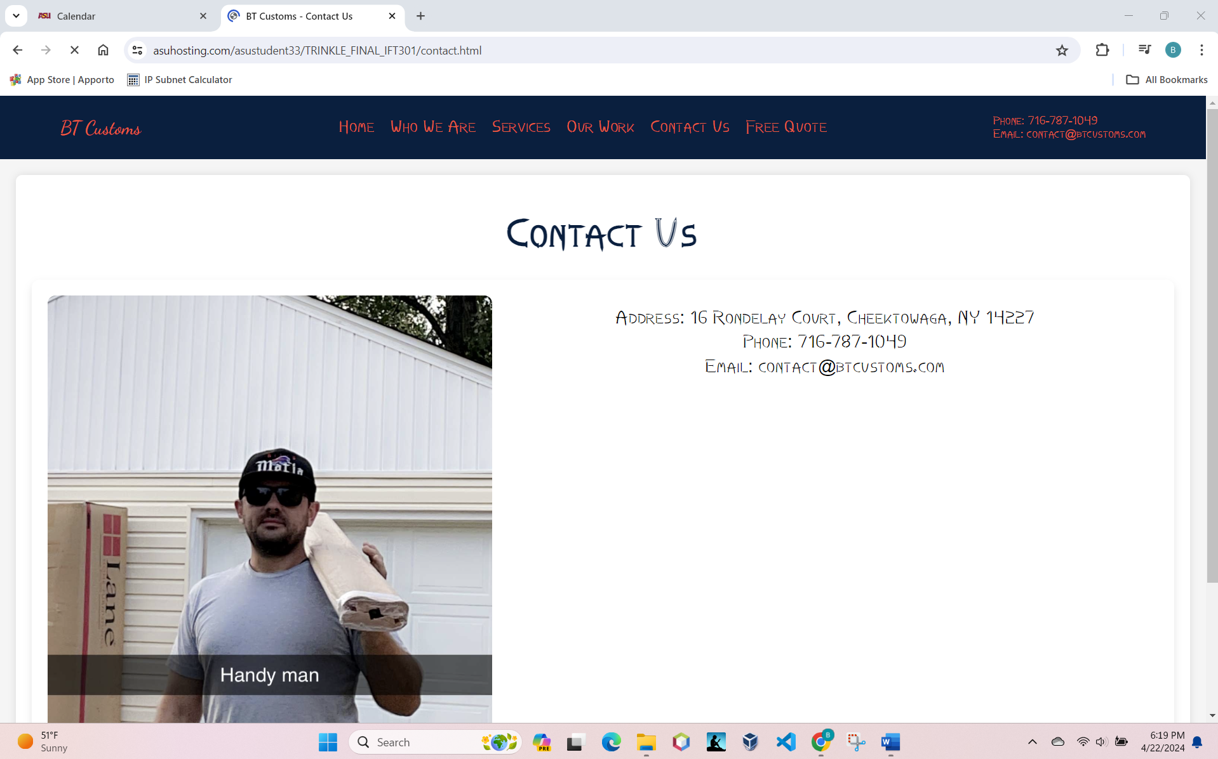

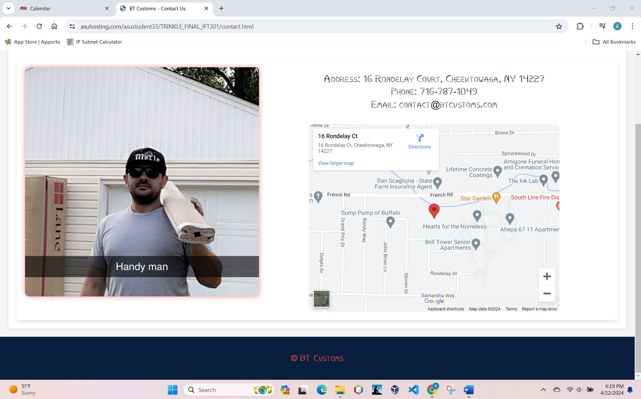

1. Insert the browser view screenshot of page #6 here.

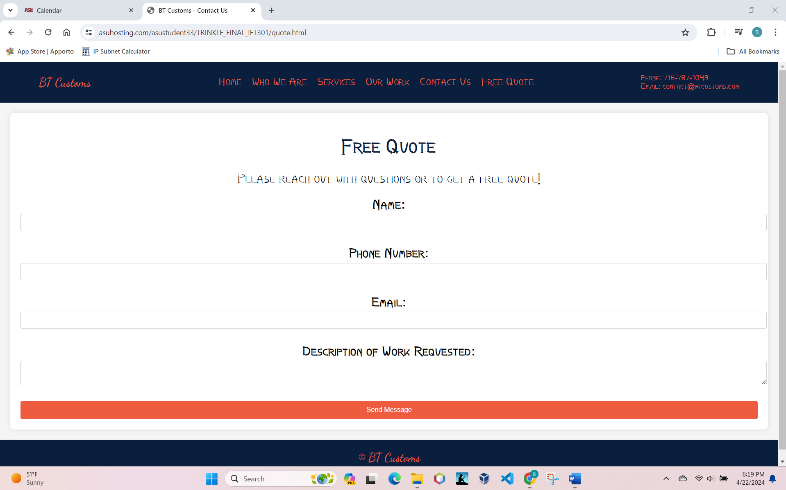

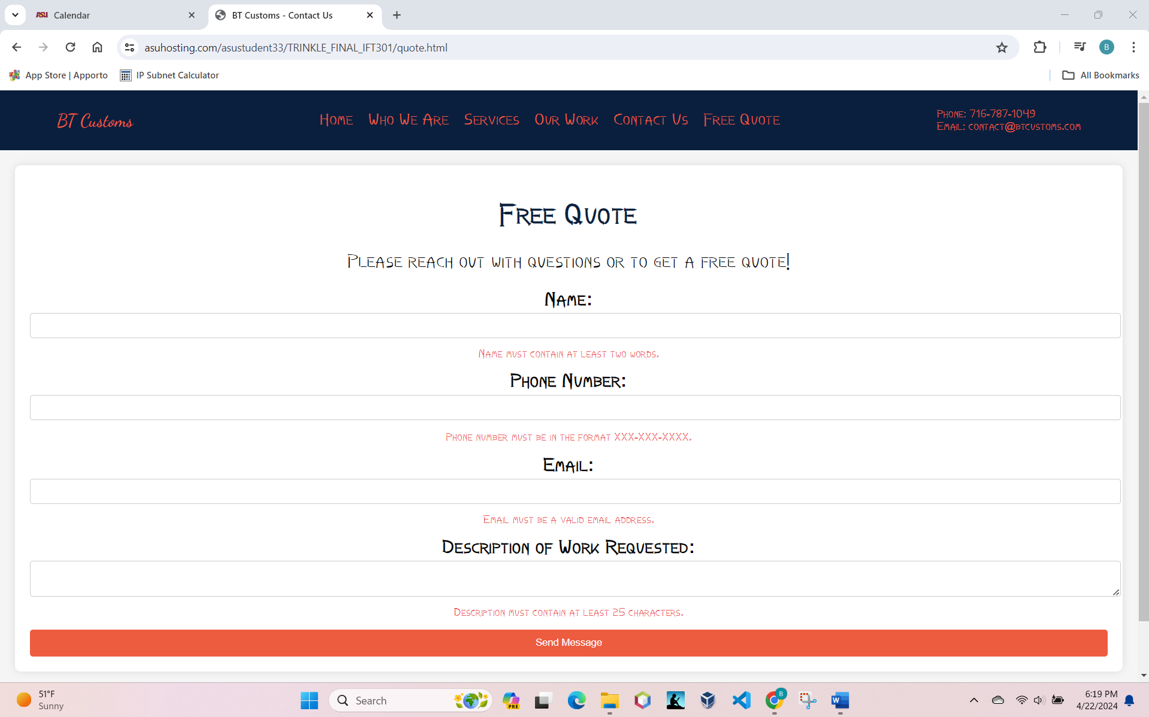

1. Copy and paste the URL for your home page here.

<https://www.asuhosting.com/asustudent33/TRINKLE_FINAL_IFT301/>